Supplementary information

An in-depth analysis of the evolution of the policy mix for the sustainable energy transition in China from 1981 to 2020

Lili Li and Araz Taeihagh
Lee Kuan Yew School of Public Policy, National University of Singapore

Appendix A1–A5 text

A1 Terms used interchangeably with “policy mix” in the literature
In the literature, terms used interchangeably with “policy mix” include “policy package(s)” [1–7], “policy bundling” [8] and “policy portfolio(s)” [9,10]. The relevant literature has been growing in recent years. A bibliography search using the Scopus database shows that the number of articles containing these keywords in the title is 241, with 182 articles published since 2010 and with 179 articles containing the term “policy mix(es)”. This study therefore uses the term “policy mix”. The keywords used for the bibliography search include “policy mix”, “policy mixes”, “policy package”, “policy packages”, “policy packaging”, “policy bundle”, “policy bundles”, “policy bundling”, “policy portfolio” and “policy portfolios”. The search is limited to literature containing any of these key words in titles.
The difference between “policy package” and “policy mix” is small and they are often used interchangeably in literature. Policy packages are often designed according to a systematic approach. A policy mix is a broader concept that can not only refer to well-designed policy packages, but also to less well-designed bundles of policy instruments formulated through processes of layering new policy instruments over a long period of time. A policy mix can not only be narrowly used to indicate a policy instrument mix, but can also be used in a much more complex context to refer to a policy mix with multiple policy instruments and programs (e.g. in the case of climate change). Following the convention in literature, this study uses “policy mix” and “policy package” as interchangeable nouns.

A2 Searching strategy for relevant policy documents
We searched for relevant Chinese policy documents to make a preliminary identification of the instrument mix serving each policy strategy. The policy documents were from the pkulaw database, which incorporates the national-level and local-level policy documents of China. In China, the central government is the main policy-making body in the electricity sector, so we limited the search to the national policy documents in this study. We searched for policy documents with titles containing the following keywords: “wind power” (feng dian or feng li fa dian), “solar PV” (guang fu), “hydroelectricity” (shui dian), “renewable energy” (ke zai sheng neng yuan), “sulfur dioxide” (er yang hua liu), “carbon dioxide” (er yang hua tan), “greenhouse gas” (wen shi qi ti), “low-carbon” (di tan), “carbon emissions” (tan pai fang) or “pollutant discharge fee” (pai wu fei). With no time limit, the initial search resulted in 1,069 policy documents, including 96 documents on “wind power”, 143 on “solar power”, 433 on “hydroelectricity”, 114 on “renewable energy”, 33 on “sulfur dioxide”, 7 on “carbon dioxide”, 15 on “greenhouse gas”, 61 on “low-carbon”, 16 on “carbon emissions” and 151 on “pollutant discharge fee”. After removing duplicates and a preliminary screening based on relevance, we downloaded the full texts of the 217 relevant policy documents (in Chinese). To establish a thorough analysis of the instrument mixes, we reviewed the relevant literature to check if there were any other important policy documents and instruments that had been missed in the initial policy document search. In the end, we performed the analysis based on a review of 237 Chinese policy documents.

A3 Coding framework
An Excel spreadsheet was used to manually record the information for the policy documents. Table A1 displays the coding framework.
Table A1. Coding framework
Primary code | Secondary code
Basics | Policy document title:____ (in Chinese)  Policy document title:____ (translated in English)  Policy document No.: ____
Temporal aspects | 1) The policy document was published on dd/mm/yyyy  2) The policy document was effective from dd/mm/yyyy  3) The policy document was terminated/amended on dd/mm/yyyy
Actors involved | The government authority (or authorities) issuing the policy document is ____  Label Key word Chinese name  SC State Council 国务院  MF Ministry of Finance 财政部  FMC Former Ministry of Construction 建设部(已撤销)  FSEPA Former State Environmental Protection Administration 国家环境保护局/总局  FSACP Former State Administration of Commodity Prices 国家物价局  FSPC Former State Planning Commission 国家计划委员会  FSDPC Former State Development and Planning Commission 国家发展计划委员会  FSETC Former State Economic and Trade Commission 国家经济贸易委员会  MOST Ministry of Science and Technology 科技部  MFA Ministry of Foreign Affairs 外交部  NPCSC Standing Committee of the National People's Congress 全国人民代表大会常委会  FSERC Former State Electricity Regulatory Commission 国家电力监管委员会  FMA Former Ministry of Agriculture 农业部  CMA China Meteorological Administration 中国气象局  FMEP Ministry of Environmental Protection 环境保护部  NEA National Energy Administration 国家能源局  MHURD Ministry of Housing and Urban-Rural Development 住房城乡建设部  MIIT Ministry of Industry and Information Technology 工业和信息化部  SAT State Administration of Taxation 国家税务总局  MOE Ministry of Education 教育部  SOA State Oceanic Administration 国家海洋局  FNEC Former National Economic Council 国家经济委员会  FMWREP Former Ministry of Water Resource and Electric Power 水利电力部  FME Former Ministry of Energy 能源部  MWR Ministry of Water Resources 水利部  ABC Agricultural Bank of China 中国农业银行  NDRC National Development and Reform Commission 国家发展和改革委员会  CPCCC CPC (Communist Party of China) Central Committee 中国共产党中央委员会(中共中央)  FMLR Former Ministry of Land and Resources 国土资源部  NPC National People's Congress 全国人民代表大会  MNR Ministry of Natural Resources 自然资源部
Policy objective | A) Reducing air pollution  B) Reducing CO₂ emission (or GHG)  C) Hydro energy related  D) Wind energy related  E) Solar energy related  F) Planning  G) Others
Policy background | Policy background mentioned in the policy document: ___
Policy content | 1) Does the policy document mention a specific policy instrument or a set of policy instruments?  Yes [Go to question 2]  No [No further questions]  2) What is the policy instrument (or, what are the policy instruments)? ____  3) Types of the policy instrument (or, what are the policy instruments)? ____  A) Nodality  B) Authority  C) Treasure  D) Organization  4) The geographic scope where the policy instrument is implemented: ___  5) Information related to stringency of the policy instrument: ___ (if applicable)

A4 Evolution of the environmental policy mixes

A4.1 Environmental policy mix between 1981 and 1990 (6th and 7th Five-Year Plans (FYPs)

A4.1.1 The background
During the 1980s, China underwent a series of economic reforms under the leadership of Deng Xiaoping; rapid economic growth was the primary national goal. In the electricity sector, the institutions saw a few changes between 1981 and 1990. In 1982, the Ministry of Water Resources and Electric Power (MWREP) was established; in 1983, environmental protection became a fundamental state policy of China during the second National Environmental Protection Conference. In 1988, MWREP was dismantled and the State Environmental Protection Administration (SEPA) was founded as a vice-ministerial-level organization, working directly under the State Council, which is the major policy-making institution. In 1988, China also established the Ministry of Energy to oversee the oil and gas, electricity, coal and nuclear energy industry, and established the Ministry of Water Resources (MWR) to oversee hydropower development. However, five years later, the Ministry of Energy was dissolved and the Ministry of Electric Power was set up to regulate the electricity industry.

A4.1.2 The policy mix
See Figure 3 in the main text.
In 1982, the Chinese government started to implement the pollutant discharge fee (PDF) for particulate matter (PM) emission abatement, but not for other air pollutants. In 1986, the Environmental Protection Management Measures for Construction Projects suggested the application of the environmental impact assessment (EIA) to new, renewed or extended construction projects in all fields. In 1989, the Environmental Protection Law suggested the use of the mandatory deadline as an instrument to enforce the polluters that could not meet the emission limits to reduce their emissions. If they could not meet the deadlines, the polluters would have penalties imposed on them or be forced to shut down.
In the 1980s, the electricity sector was monopolized by the state. For instance, the Administrative Regulations on Hydraulic and Hydropower Projects in 1983 stated that hydropower projects had to meet production targets set by the government. China started to encourage rural hydropower projects to utilize the dispersal of water resources and increase access to electricity in rural areas. At the end of 1983, the State Council and the former MWREP launched a program to develop the 100 rural electrification counties through small-scale hydropower projects. To support the program, the government used measures such as preferential tax, concessional loan, material and technical support and direct subsidies. In 1986, the Regulations on the Price of Small Hydropower suggested that the local governments could set the electricity tariff for small hydropower based on the principle of “cost plus reasonable profit.”

A4.2 Environmental policy mix between 1991 and 1995 (8th FYP)

A4.2.1 The background
Radical economic reforms continued in the 1990s under the leadership of Deng Xiaoping, who was followed by Jiang Zemin. Nonetheless, China still ratified the United Nations Framework Convention on Climate Change (UNFCCC) in 1993, which became effective in 1994.

A4.2.2 The policy mix
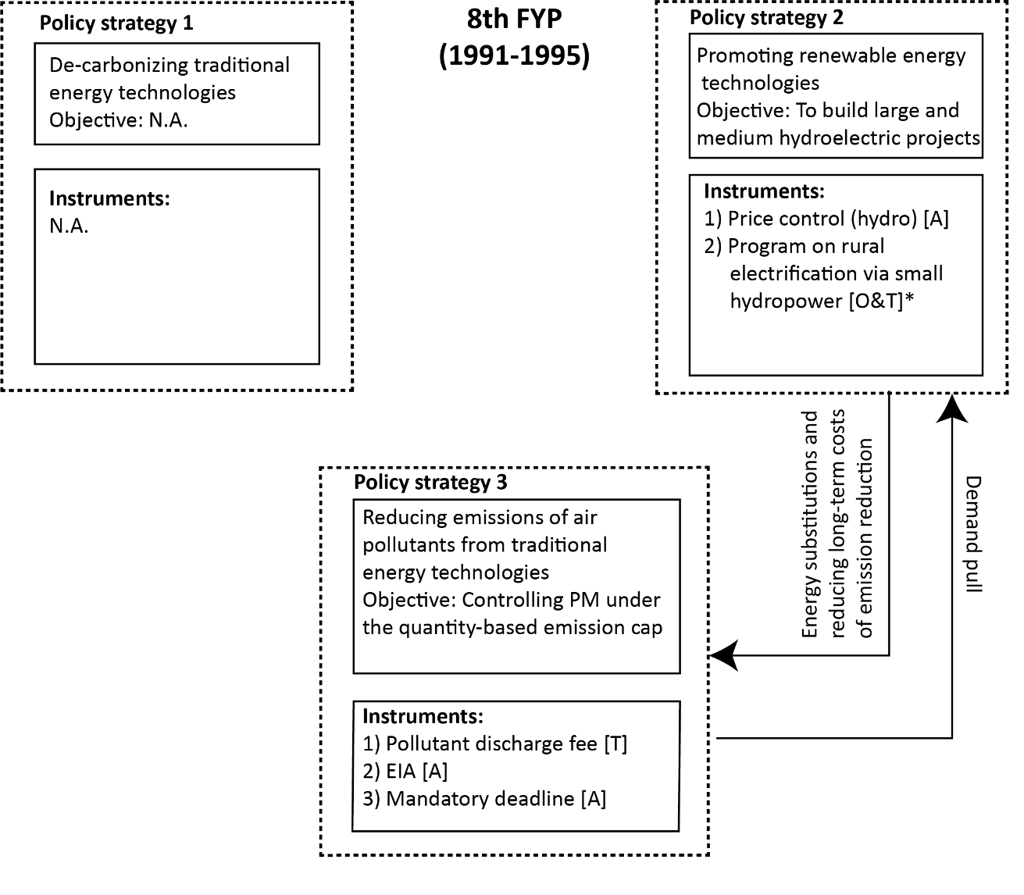
Figure A1. Policy mix, 1991–1995
Note: The letters in the square brackets show the policy instrument types according to the NATO model. “N” – nodality; “A” – authority; “T” – treasure; and “O” – organization. * denotes that the program involves multiple types of policy instrument.

China started to apply the PDF to SO₂ in some pilot schemes. The SO₂ discharge fee was applicable to coal-fired power plants and other industrial sectors that consumed coal, and the charging rate was no more than 0.2 yuan/kg. To encourage small rural hydropower, the State Council and the MWR announced a decision in 1991 to develop an additional 200 rural electrification counties through building small hydropower projects. The project developers were required to allocate 0.02 yuan/kWh of the generated electricity to establish a Rural Hydropower Development Fund, which could be used for future rural hydropower development.

A4.3 Environmental policy mix between 1996 and 2000 (9th FYP)

A4.3.1 The background
In 1998, SEPA was upgraded from vice-ministerial level to ministerial level, meaning that SEPA became more powerful when implementing environmental policies. In the electricity sector, the Ministry of Electric Power was dissolved in 1998; its functions were taken over by the State Economic and Trade Commission (SETC) and the State Power Corporation, which aimed to separate the government regulatory functions and commercial activities [11,12]. At the international level, China signed the Kyoto Protocol in 1998, which came into effect in February 2005.

A4.3.2 The policy mix
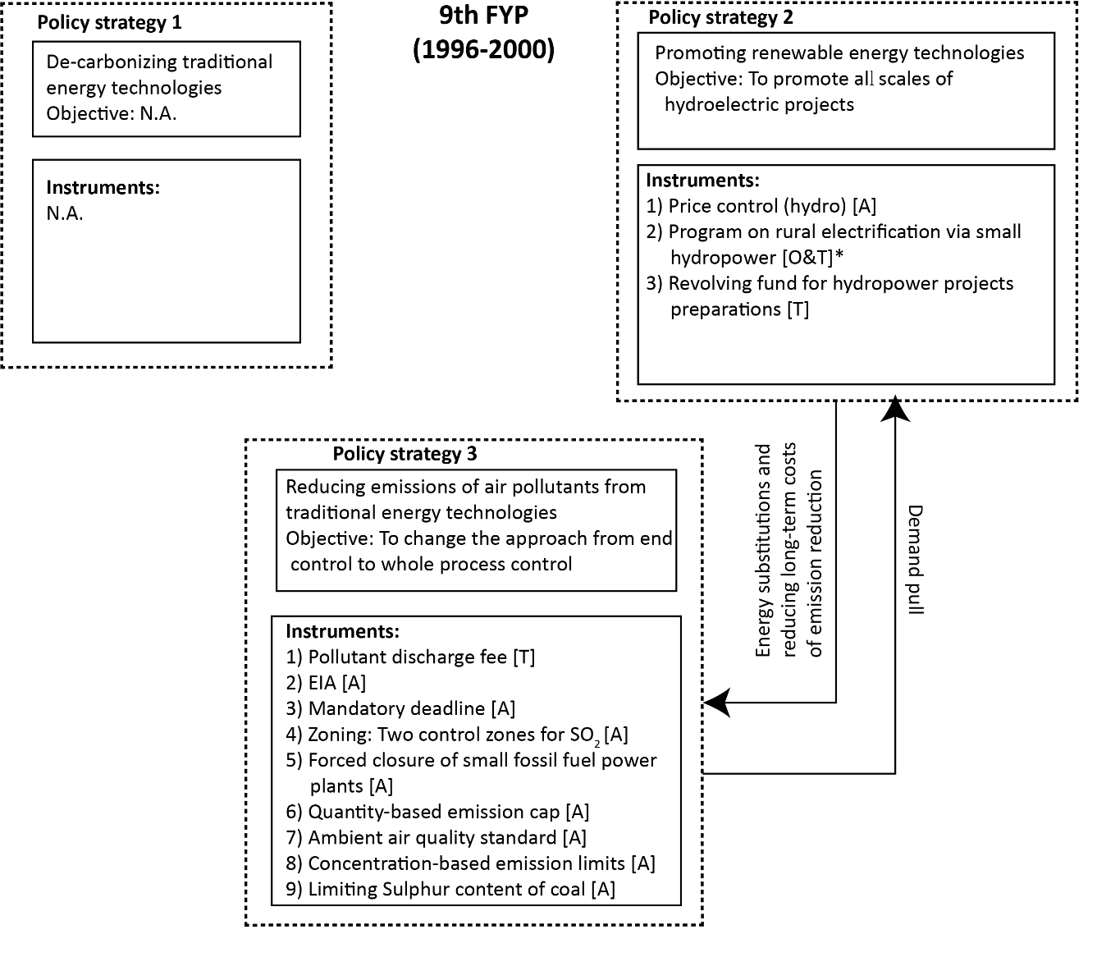
Figure A2. Policy mix, 1996–2000
Note: The letters in the square brackets show the policy instrument types according to the NATO model. “N” – nodality; “A” – authority; “T” – treasure; and “O” – organization. * denotes that the program involves multiple types of policy instrument.

In 1996, the State Council agreed with SEPA about expanding the implementation area of the SO₂ discharge fee from the 11 pilots to the major acid rain and SO₂ control areas. After two years, the government defined the geographical scope of the acid rain control zone and the SO₂ emission control zone (referred to here as the “two control zones”, or TCZ). In 1998, the State Council stated that, within the TCZ, the policy objective was to stabilize the SO₂ emissions in 2010 at the 2000 level, so there should be no increase of annual emission levels from 2000 onwards. A package of policy instruments was suggested to achieve the objective within the TCZ, including the quantity-based emission cap (also referred to as “total amount control” in some literature), concentration-based emission limits, air quality standards, limiting the sulfur content of coal and the PDF.
By the end of the 1990s, the gap between electricity supply and electricity demand had narrowed. At this juncture, the former SETC requested shutting down small-sized fossil fuel power plants in 1999 with the goal of reducing air pollutants and enhancing efficiency in resource utilization. With respect to the renewable energy support, the Ministry of Finance initiated the Revolving Fund for Hydropower Preparatory Work in 1997; this served hydropower development until 2003. The hydropower projects could use the fund for project planning and preparations by paying the occupancy fee, which was lower than the interest rate on bank loans.

A4.4 Environmental policy mix between 2001 and 2005 (10th FYP)

A4.4.1 The background
In 2003, President Hu Jintao initiated the “scientific development perspective” (ke xue fa zhan guan) to guide socioeconomic development, with an emphasis on sustainable development and social welfare. In the electricity sector, China initiated the reform to increase market competition. The State Power Corporation was dismantled over 2002–2003; its successors included five state-owned power generation enterprises and two state-owned power grid enterprises. In 2003, the State Council released the Plan of the Electricity Price Reform, dividing the on-grid electricity price, the transmission price, the distribution price and the retail price. The 2002 electricity sector reform led to some degree of market liberalization, providing opportunities for renewable energy project developments. In 2003, the National Development and Reform Commission (NDRC) was established; this had broad administrative and planning control over the economy of China, including the role of promoting sustainable development strategy and coordinating energy development.

A4.4.2 The policy mix
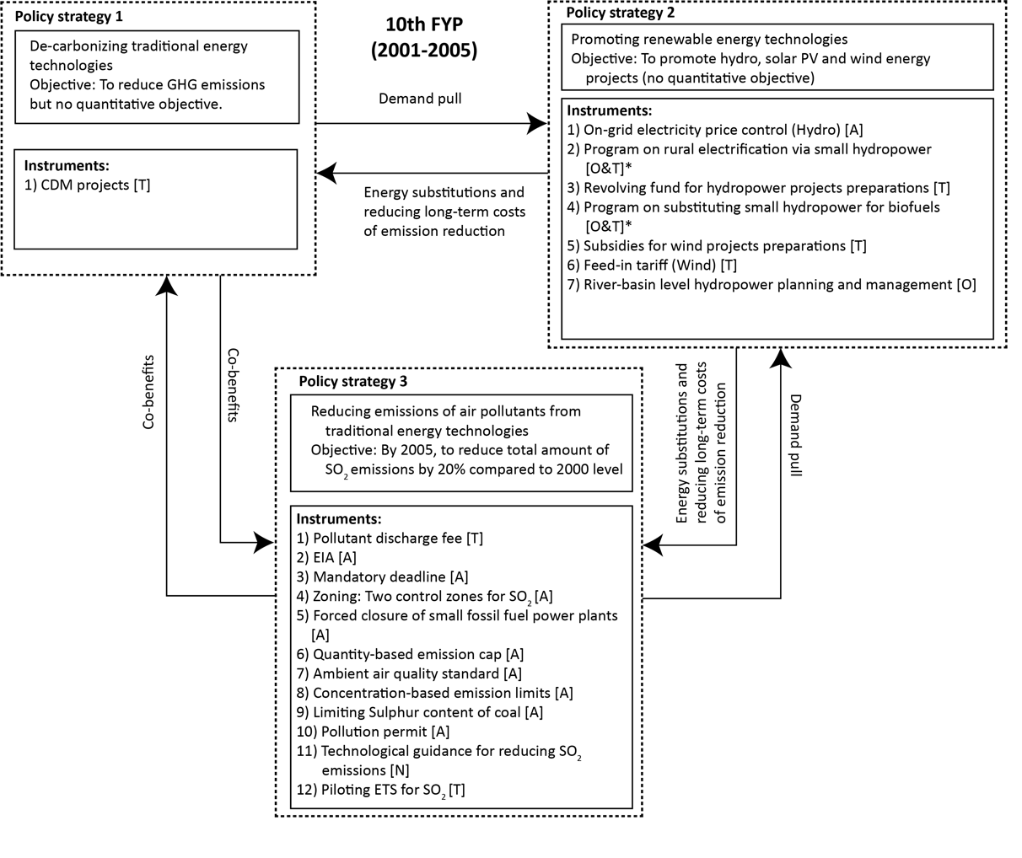
Figure A3. Policy mix, 2001–2005
Note: The letters in the square brackets show the policy instrument types according to the NATO model. “N” – nodality; “A” – authority; “T” – treasure; and “O” – organization. * denotes that the program involves multiple types of policy instrument.

To reduce SO₂ emissions in the TCZ, the State Council decided to implement the environmental target responsibility instrument, which set SO₂ mitigation targets for local governments. In addition, SEPA piloted the SO₂ Emission Trading Scheme (ETS) in nine cities and four provinces. In July 2003, the applicable scope of the PDF was expanded beyond the TCZ. The charging rate on SO₂ emissions increased from 0.2 yuan/kg to 0.6 yuan/pollutant equivalent (PE), and the NOx emission started to be charged at a rate of 0.6 yuan/PE in July 2004. In 2004, SEPA tightened up the concentration limits of SO₂ emissions for coal-fired power plants.
From 2003, the NDRC approved a series of wind power concession projects and provided fixed subsidies to cover the costs of project preparations. The government selected concession project developers through a competitive tender system (the concession period was 20–25 years). The on-grid electricity prices of the projects followed the bidding prices.
The MWR continued to regulate hydropower development. In 2001, the MWR encouraged local governments to provide financial support for the hydroelectricity-based rural electrification program. The ratio of the subsidy from the provincial government versus the subsidy from the central government was set at 2:1 in most areas, and no less than 1:1 in extremely low-income areas. In 2003, the MWR launched the Program on Substituting Small Hydropower for Biofuels. The program layered the policy goal of reducing the ecological damage onto the policy goal of developing small rural hydropower capacity. It encouraged rural households to use electricity instead of biofuels for cooking and heating.
With the Kyoto Protocol effective from 2005 onwards, China operated about half of all of the Clean Development Mechanism (CDM) projects worldwide and gained substantial economic profits from them [13]. As many projects were renewable energy projects, operating the CDM had a positive effect on China’s renewable energy development.

A4.5 Environmental policy mix between 2006 and 2010 (11th FYP)

A4.5.1 The background
To address climate change-related issues, China established a National Leading Group on Climate Change in 2007. It consisted of officials from multiple agencies and fell under the authority of the NDRC. In 2008, the National Energy Administration (NEA) was established under the NDRC to address energy-related affairs. In March 2008, the government upgraded SEPA (ministerial level) to the Ministry of Environmental Protection (MEP, cabinet level) to enhance the regulatory enforcement of environmental protection policies. SEPA was allowed to offer its opinions to the State Council but did not have a direct influence on the major economic and social development decisions. The MEP, however, was a cabinet-level department of the State Council, and had the legal authority to influence the State Council’s decisions, including strengthening the environmental protection measures in the FYPs. As such, the MEP’s opinions were less likely to be neglected [14].

A4.5.2 The policy mix
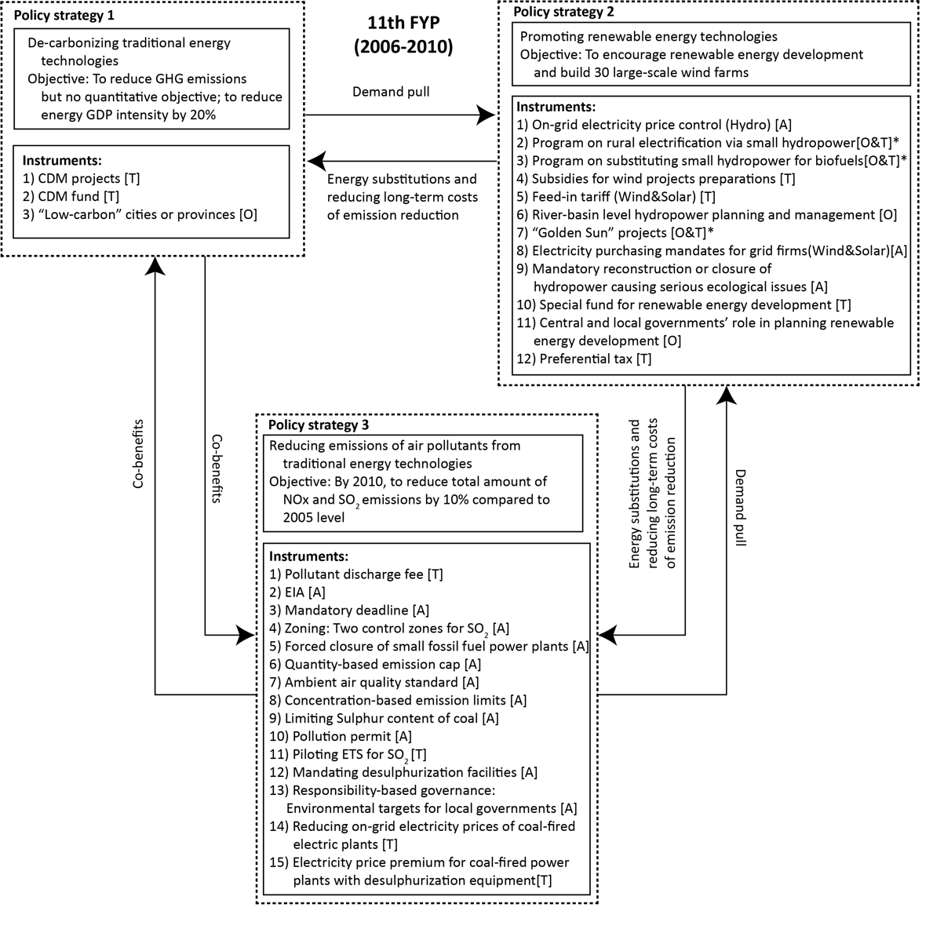
Figure A4. Policy mix, 2006–2010
Note: The letters in the square brackets show the policy instrument types according to the NATO model. “N” – nodality; “A” – authority; “T” – treasure; and “O” – organization. * denotes that the program involves multiple types of policy instrument.

In April 2007, the NDRC decided to shut down small coal-fired power plants; this was facilitated by the instrument of reducing the on-grid electricity price of these power plants. The policy goal was to enhance energy savings and emission abatement in the electricity sector. In July 2007, to reduce SO₂ emissions, the government implemented an electricity price premium for coal-fired power plants with desulphurization equipment. The premium was 0.015 yuan/kWh, which was added to the on-grid electricity price.
A cornerstone of China’s renewable energy development is the Renewable Energy Law, issued in 2005 and effective from 2006. It put in place a package of policy instruments, including Feed-In Tariffs (FITs). Accordingly, (1) for solar power projects, the on-grid electricity price should be determined by the government authorities following the principle of “reasonable costs plus reasonable profits”; (2) for wind power projects, the government regulates the on-grid electricity price with reference to the successful bidding price; and (3) grid firms are obliged to buy renewable electricity and they can levy surcharges on electricity consumers to cover the extra costs.
Between 2006 and 2010, the NDRC approved the tariff values for several FIT projects. For wind power projects, the tariff rates varied between 0.51 and 0.61 yuan/kwh. For solar power projects, the tariff rate was higher, ranging from 1.15 to 4 yuan/kwh. Hydropower projects were facing stricter environmental requirements. In 2006, SEPA and the MWR addressed the application of the EIA to hydroelectric projects. In August 2006, the MWR suggested shutting down some hydropower stations that were inefficient in operation and had negative environmental impacts.
In July 2009, the government launched the “Golden Sun” demonstration projects to encourage the deployment of solar photovoltaic (PV) technologies. To facilitate the implementation of the projects, subsidy schemes were used, including a subsidy that covered 50% of the major capital costs of on-grid projects and 70% of the major capital costs of off-grid projects, with a subsidy of 4 yuan/kwh for on-grid projects and 10 yuan/kWh for off-grid projects to cover other costs.
In 2010, the NDRC launched the “Low-Carbon Provinces” and “Low-Carbon Cities” pilots, which could be considered as city-branding exercises [15]. The central government did not assign specific CO₂ mitigation targets but gave local governments the autonomy to adopt innovative policy instruments to explore low-carbon development pathways.

A4.6 Environmental policy mix between 2011 and 2015 (12th FYP)

A4.6.1 The background
In June 2015, in response to international pressures and the domestic demand for a sustainable transition, China submitted the report Enhanced Actions on Climate Change: China’s Intended Nationally Determined Contributions (INDC) to the Secretariat of the UNFCCC and committed to decreasing CO₂ emission intensity by 60%–65% relative to 2005 levels by 2030, as well as to increasing the share of non-fossil fuel energy in the primary energy consumption to 20% by 2030 [16]. In the electricity sector, the government kicked off another round of market-oriented reforms in 2015 [17]. The reforms were intended further to liberalize the electricity market and to promote distributed electricity projects, as well as the efficient utilization of renewable electricity.

4.6.2 The policy mix
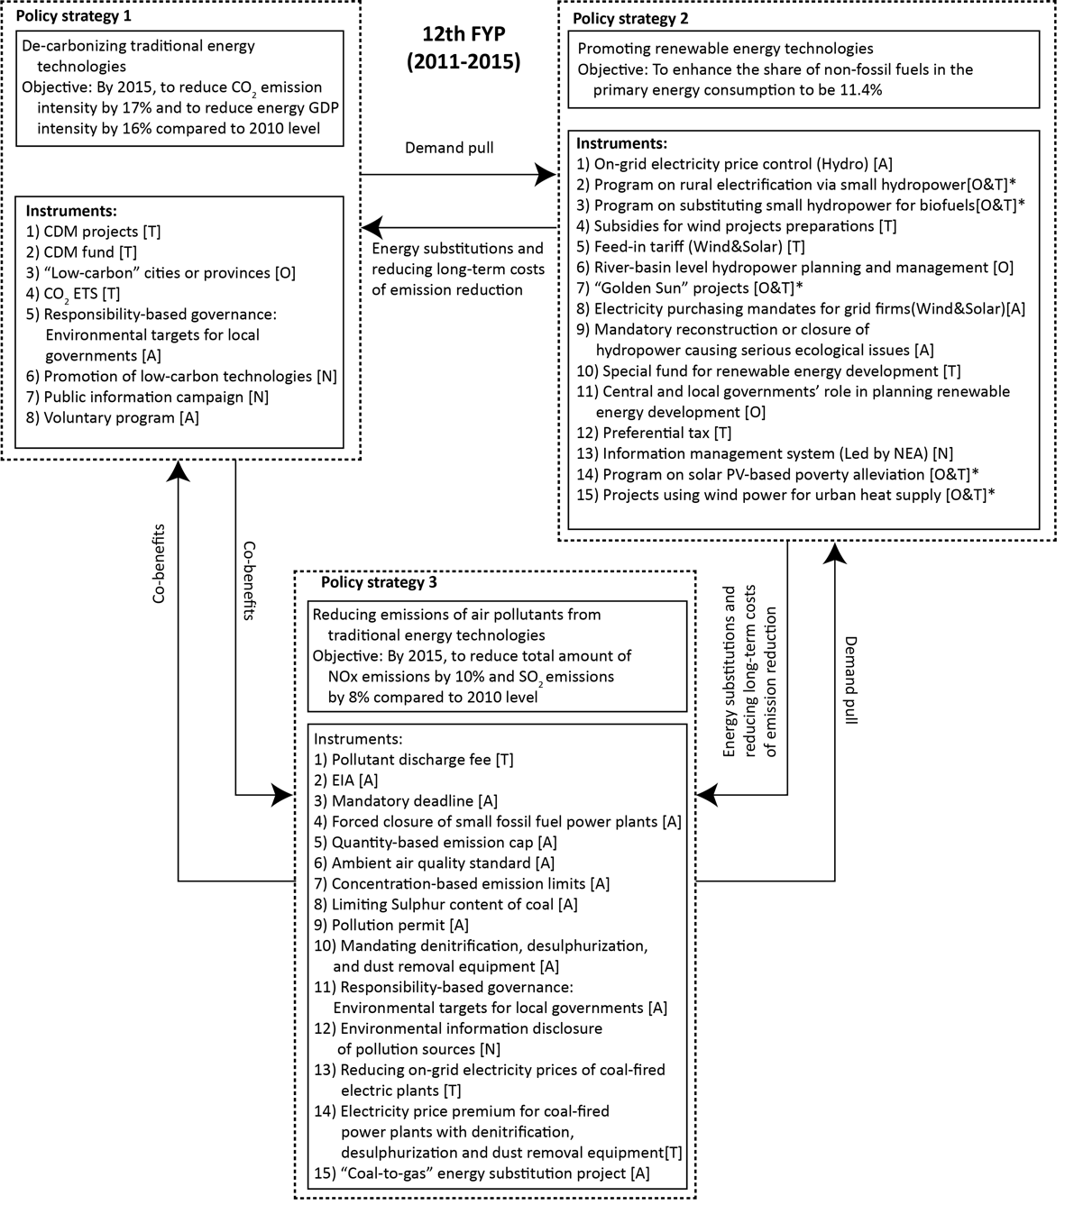
Figure A5. Policy mix, 2011–2015
Note: The letters in the square brackets show the policy instrument types according to the NATO model. “N” – nodality; “A” – authority; “T” – treasure; and “O” – organization. * denotes that the program involves multiple types of policy instrument.

In 2013, to reduce air pollutants from conventional energy technologies, the State Council suggested implementing the electricity price premium (huan bao dian jia) for coal-fired power plants with denitrification, desulphurization and dust removal equipment (referred to as “environmental equipment”). Subsequently, the NDRC specified that the premium would be 0.002 yuan/kWh for the use of dust removal equipment and 0.01 yuan/kWh for the use of denitrification equipment. In January 2015, the amended Environmental Protection Law came into effect. The amendments emphasized the use of nodality instruments, including educating students with a knowledge of environmental protection at schools, educating the public through the media and disclosing the sources of environmental emissions.
The renewable energy support strategy had a more complex instrument mix. In terms of hydroelectric projects, the government continued to emphasize the unintended environmental impacts. In October 2011, the NDRC and MEP decided on applying the EIA instrument to both hydroelectric projects and the river-level hydroelectricity development plans. Regarding solar PV technologies, in August 2013, the NDRC differentiated the policy instruments for distributed and centralized solar PV systems. For centralized solar PV systems, the tariff rates of FIT in categories I, II and III solar resource zones were 0.90, 0.95 and 1.00 yuan/kwh with the highest tariff rate for regions with the richest solar resources. The contract duration was up to 20 years and the tariffs subject to re-evaluation. For distributed solar PV projects, the owners could sell the whole electricity to grid companies at the same price as the centralized solar PV systems. Alternatively, the owners could self-use some amount of the electricity and sell the rest to the grid companies at the same price as the coal-fired electricity. As such, in the second scenario, the owners would not only enjoy a subsidy of 0.42 yuan/kwh for every unit of the generated electricity (self-used or not); they would also have the revenue from the sales of the remaining electricity. In October 2014, the State Council and the NEA launched a solar PV-based poverty alleviation program, layering the poverty alleviation on the goal of distributed solar power deployment. The program led to the installation of solar PV panels by low-income households, which would earn additional income due to the program.
With respect to wind energy technologies, wind electricity curtailment became an issue (especially in Jilin, Inner Mongolia, Gansu, Ningxia, Xinjiang and Heilongjiang) due to a lack of local demand, poor grid access and inadequate transmission capacity. In June 2015, the NEA launched a demonstration program on using wind electricity for urban heat supply, aiming to increase the local demand for wind electricity. In September 2015, the NEA decided to establish the information management system (IMS) for renewable energies to balance supply and demand.
To address the objective of reducing CO₂ emission intensity directly, an important policy change was, first, the implementation of the CO₂ ETS pilots from 2013. Second, the Top-10,000 Enterprises Energy Saving and Low-Carbon Program in 2011–2015 contributed to achieving the objectives of energy savings and CO₂ mitigation. It was a program through which enterprises reached agreements on energy conservation with the government; the policy goal was to achieve a total of 250 million tons of coal-equivalent energy savings. It incorporated 16,018 enterprises, which accounted for about 60% of the total national energy consumption in 2011 [18]. Third, the central government started to set local targets for CO₂ emission intensity reduction and the NDRC publicized how far the local governments had gone toward reaching their targets. Fourth, a few nodality instruments were implemented, including the promotion catalogue of low-carbon technologies and public information campaigns during a “National Energy Conservation Week” and a “National Low-Carbon Day”.

A4.7 Environmental policy mix between 2016 and 2020 (13th FYP)

A4.7.1 The background
In April 2018, the Ministry of Ecology and Environment (MEE) was inaugurated, replacing the MEP. The MEE took over the responsibility of tackling climate change-related issues, which used to be the duty of the NDRC, so that the CO₂ mitigation instruments could be better coordinated with the air pollution abatement instruments. In addition, the MEE took over environmental protection affairs that had been scattered across other agencies and ministries (including the former Ministry of Land and Resources, the MWR, the former Ministry of Agriculture and the former State Oceanic Administration) aimed at coordinating policies for all dimensions of the environment protection.

A4.7.2 The policy mix
See Figure 4 in the main text.
In January 2016, the NDRC decided to implement an electricity price premium of 0.01–0.005 yuan/kWh for coal-fired power plants, reducing emissions to a specified lower level. The Ambient Air Quality Standards (GB 3095-2012) became effective on January 1, 2016. In the previous Ambient Air Quality Standards (GB 3095-1996), the government set different emission limits for three types of area. The daily (24 hours) concentration limits for SO₂ was 0.05 mg/m³ for class I areas, which are special areas, such as national parks; 0.15 mg/m³ for class II areas, which are urban and most industrial areas; and 0.25 mg/m³ for class III areas, which are special industrial areas. In GB 3095-2012, the MEP increased the policy strictness by setting two types of SO₂ concentration limits only: 0.05 mg/m³ for class I areas, such as national parks; and 0.15 mg/m³ for all other areas. In 2018, the important environmental policy change was the replacement of the pollution discharge fee with environmental taxation. The tax rate for SO₂ (or NOx) was set at 1.2–12 yuan/PE, which can be determined by the local government, according to the local context.
With respect to renewable energy support, the government has made efforts to achieve the grid-parity pricing of renewable electricity and reduce the unintended curtailment issues. On January 1, 2016, the Air Pollution Prevention and Control Law (2015 Amendments) stated that the dispatching priority should be given to renewable electricity. To reduce the unintended curtailment issue, in 2016, the NDRC further pushed the guarantees of renewable electricity purchases by grid firms. In addition, the government has implemented market monitoring and early warning instrument for solar PV since 2016 and for the wind industry since 2017. The instrument labels the market condition of different provinces, suggesting to investors not to invest in new renewable electricity installations in areas that have a curtailment risk. In January 2017, the NDRC, the NEA and the Ministry of Finance decided to conduct a trial implementation of tradable green certificate (TGC), aimed at reducing the government’s subsidy costs. In May 2017, the NEA launched the grid-parity pricing projects for wind electricity. In September 2017, the NEA launched the “Leader” solar PV projects; these focused on the research, development and demonstration of technologies, aiming to push technology innovation and decrease the production costs of solar electric power.
For hydroelectric development, in May 2016, the NDRC and the MWR launched the piloting projects of Rural Small Hydropower for Poverty Alleviation, layering the poverty alleviation goal on the goal of rural hydropower development. In June 2017, the MWR launched the program “Green” Small Hydropower Stations, which would label some small hydropower stations as “green” provided that they met certain environmental criteria. To address the ecological issues incurred by the rapid expansion of small hydropower in the Yangtze River Economic Belt, in May 2018, the MWR, NEA and NDRC together decided to conduct a thorough investigation into small hydropower projects in the region, retrofitting or shutting down those causing serious ecological problems.

A5 Interactions between policy instruments
Accordingly, 1) precondition refers to cases where a policy instrument is strictly required for the successful implementation of another; 2) facilitation refers to cases where the successful implementation of a policy instrument can make another policy instrument work better; 3) synergy refers to cases where two policy instruments “facilitate” each other; 4) potential contradiction refers to cases where two policy instruments conflict in terms of outcomes or incentives given certain contingencies; and 5) contradiction refers to cases where two policy instruments generate “strictly” conflicting outcomes or incentives.
Figure 6 illustrates the policy interactions, not only within a single policy instrument mix (policy package) but also between various between instrument mixes (policy packages) addressing different strategies in the 13th FYP. For the policy strategy of directly addressing CO₂ mitigation, the central government utilizes the responsibility-based governance approach by setting CO₂ emission intensity reduction targets for local governments. Other policy instruments, such as CO₂ ETS, the CDM Fund and public information campaigns, all facilitate the achievement of the local CO₂ mitigation targets. The CO₂ ETS so far works in the piloting areas, while the CDM Fund serves as a financial source for nationwide climate actions.
To reduce air pollutants from coal-fired power plants, the MEP, together with the NDRC, has implemented two process-oriented policy instruments since 2014: 1) mandating denitrification, desulphurization and dust removal equipment; and 2) setting an electricity price premium for units with that environmental equipment. The latter facilitates the implementation of the former by mitigating the cost barriers of installing those equipment. The mandatory instrument suggests the government’s willing to push through mandatory environmental equipment among the coal electricity plants, but the implementation effectiveness has not been as high as intended due to the high costs of installing and operating the equipment. As such, the electricity price premium works as an interim instrument to provide economic incentives. The two instruments constitute a combination of “carrots and sticks” [19], but when the environmental equipment is prevalent among the coal-fired power plants in the future, the incentive of the price premium may seem unnecessary and can be phased out to improve overall cost efficiency. The environmental protection tax can facilitate the implementation effectiveness of the electricity price premium by providing additional incentives for electricity plants to install environmental equipment. The electricity price premium also helps achieve the goal of the environmental protection tax, which is pollution abatement. As such, there is a synergistic interaction between the environmental protection tax and the electricity price premium for installing and operating environmental equipment. Reducing the overall on-grid prices of coal electricity could enhance the salience of the premium, facilitating the implementation effectiveness of the electricity price premium.
There is a synergistic interaction between the environmental protection tax and the CO₂ mitigation targets for local governments. The environmental protection tax provides the incentive for electricity generators to reduce air pollutant emissions, which can result in the reduction of the co-emitted CO₂. On the other hand, local CO₂ mitigation targets can also motivate energy-related mitigation actions, contributing to local air pollution abatement.
FIT has two precondition instruments: the Special Fund for Renewable Energy Development and the renewable electricity purchasing mandates for grid firms. The former provides the financial source, while the latter addresses the demand risk. The instrument of reducing the on-grid price of coal electricity facilitates FIT by discouraging investments in new coal electricity plants. FIT can facilitate the achievement of the local CO₂ mitigation targets because it can increase the local deployment of renewable energy resources with cost-sharing by the nationwide electricity consumers and taxpayers.
Many studies have examined the interactions between ETS, FIT and TGC. The interactions depend on the detailed design of the three instruments [20,21]. Given that the policy design of the national CO₂ ETS or the TGC has not been decided by the policy-makers, there are uncertainties regarding the interactions between the three policy instruments.
The literature shows a debate on the suitability of FIT or TGC as the main renewable energy support instrument [22]. In practice, FIT is more prevalent across countries. FIT can promote technologies with different costs and maturity levels, whereas the lowest cost and most mature renewable energy technologies tend to be economically competitive in the TGC market [23,24]. A TGC combined with a renewable portfolio standard (RPS) has the advantage of lower costs and government interventions, but there are problems of higher market risks for electricity generators, inferior effects on technology innovation and a higher cost burden for electricity consumers [25–28].
In China, the TGC is at a trial implementation stage. A potential contradiction between FIT and TGC exists when the TGC is formally implemented in combination with RPS in future. If FIT and the TGC target all renewable energy technologies together, FIT may undermine the incentive of the TGC instrument. Given the flaws of the TGC and the limited market competition in the electricity sector, the TGC is unlikely to entirely replace FIT any time soon in China. One option is to use FIT as the dominant instrument, especially for solar PV or other expensive renewable technologies, while the TGC can be used for some mature and low-cost technologies, such as wind or hydroelectricity.
ETS sets a price for CO₂ emissions, indicating an additional cost for coal-fired electricity plants, giving them the incentives to adopt low-carbon technologies [25,29]. However, ETS alone cannot provide sufficient incentives for technology innovation, and instruments such as FIT or TGC are needed to encourage the diffusion and innovation of renewable energy technologies [24,30,31]. The electricity-pricing mechanism is important for understanding the interaction between CO₂ ETS and FIT (or TGC). In China, the government currently regulates the on-grid electricity price, the transmission price and the retail price separately. Given the FIT in implementation and the regulated electricity prices, the additional costs on CO₂ emissions brought by ETS will not be passed on to the on-grid price of coal electricity, leading the coal electricity generators to bear the emission abatement costs and bringing extra incentives for investment in renewable energy technologies. When the national CO₂ ETS starts to operate in China and the CO₂ price is high enough, there may be some leeway to reduce the tariff rates of the FIT [32].
On the other hand, renewable energy support instruments will result in low demand for CO₂ emission allowances in the electricity sector and the collapse of CO₂ prices [33–35]. The option is to tighten up the CO₂ emission cap, adjusting it to future renewable energy deployment. For instance, Wu et al. [36] found that, when implementing both CO₂ ETS and renewable energy support instruments, the emission cap should decrease by 0.3% annually to maintain CO₂ price stability and achieve China’s INDC by 2030. If the national-level CO₂ emission cap is already in place, the renewable energy support instruments exist only to induce the decrease of CO₂ prices and to substitute a more costly emission abatement approach for what would have occurred otherwise, not producing CO₂ emissions below the emission cap [37,38].
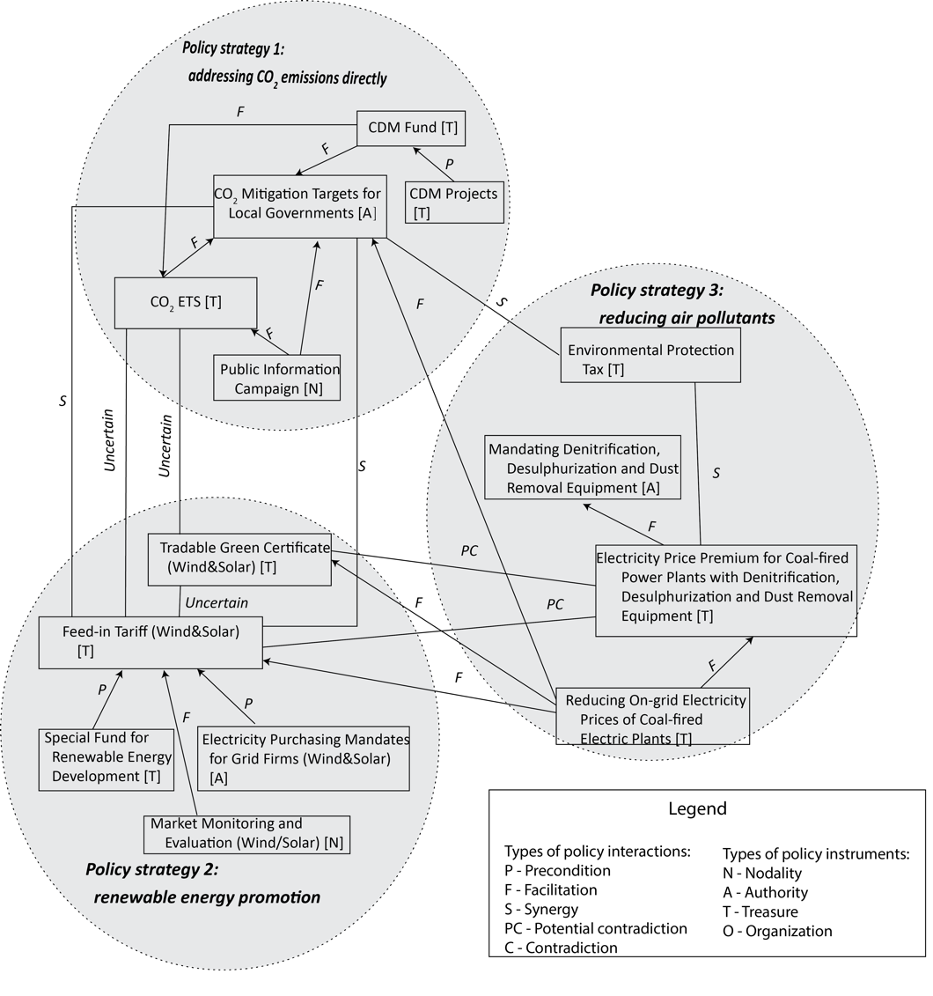
Figure A6. Policy interactions over the period of the 13th FYP (2016–2020)

Reference
[1] Givoni M. Addressing transport policy challenges through policy-packaging. Transp Res Part A Policy Pract 2014;60:1–8. doi:10.1016/j.tra.2013.10.012.
[2] Taeihagh A, Bañares-Alcántara R, Millican C. Development of a novel framework for the design of transport policies to achieve environmental targets. Comput Chem Eng 2009;33:1531–45. doi:10.1016/j.compchemeng.2009.01.010.
[3] Taeihagh A, Givoni M, Bañares-Alcántara R. Which policy first? A network-centric approach for the analysis and ranking of policy measures. Environ Plan B Plan Des 2013;40:595–616. doi:10.1068/b38058.
[4] Givoni M, Macmillen J, Banister D, Feitelson E. From policy measures to policy packages. Transp Rev 2013;33:1–20. doi:10.1080/01441647.2012.744779.
[5] Anonymous. Details omitted for double-blind reviewing 2014.
[6] Anonymous. Details omitted for double-blind reviewing 2017.
[7] Sørensen CH, Isaksson K, Macmillen J, Åkerman J, Kressler F. Strategies to manage barriers in policy formation and implementation of road pricing packages. Transp Res Part A Policy Pract 2014;60:40–52. doi:10.1016/j.tra.2013.10.013.
[8] Milkman KL, Mazza MC, Shu LL, Tsay CJ, Bazerman MH. Policy bundling to overcome loss aversion: a method for improving legislative outcomes. Organ Behav Hum Decis Process 2012;117:158–67. doi:10.1016/j.obhdp.2011.07.001.
[9] Howlett M, How YP, del Río P. The parameters of policy portfolios: verticality and horizontality in design spaces and their consequences for policy mix formulation. Environ Plan C Gov Policy 2015;33:1233–45. doi:10.1177/0263774X15610059.
[10] Doremus H. A policy portfolio approach to biodiversity protection on private lands. Environ Sci Policy 2003;6:217–32. doi:10.1016/S1462-9011(03)00036-4.
[11] Xu Y-C. A powerhouse reform: Conversion from the Ministry of Electric Power to the State Power Corporation of China. Aust J Polit Sci 2001;36:123–43. doi:10.1080/10361140020032223.
[12] Wang Q, Chen X. China’s electricity market-oriented reform: from an absolute to a relative monopoly. Energy Policy 2012;51:143–8. doi:10.1016/j.enpol.2012.08.039.
[13] Chen G. China’s climate policy. New York: Routledge; 2012.
[14] Qiu X, Li H. China’s environmental super ministry reform: background, challenges and the future. Environ Law Report 2009;2:10152–63.
[15] de Jong M, Yu C, Joss S, Wennersten R, Yu L, Zhang X, Ma X. Eco city development in China: addressing the policy implementation challenge. J Clean Prod 2016;134:31–41. doi:10.1016/j.jclepro.2016.03.083.
[16] NDRC of China. Enhanced actions on climate change: China’s Intended Nationally Determined Contributions (INDCs). Submitted to UNFCCC. National Development and Reform Commission, China; 2015.
[17] Zeng M, Yang Y, Wang L, Sun J. The power industry reform in China 2015: policies, evaluations and solutions. Renew Sustain Energy Rev 2016;57:94–110. doi:10.1016/j.rser.2015.12.203.
[18] Lo K, Li H, Wang M. Energy conservation in China’s energy-intensive enterprises: an empirical study of the Ten-Thousand Enterprises Program. Energy Sustain Dev 2015;27:105–11. doi:10.1016/j.esd.2015.05.002.
[19] Bemelmans-Videc M-L, Rist RC, Vedung EO. Carrots, sticks and sermons: policy instruments and their evaluation. New Jersey, USA: Transaction Publishers; 1998.
[20] Iychettira KK, Hakvoort RA, Linares P, de Jeu R. Towards a comprehensive policy for electricity from renewable energy: Designing for social welfare. Appl Energy 2017;187:228–42. doi:10.1016/j.apenergy.2016.11.035.
[21] Ringel M. Fostering the use of renewable energies in the European Union: the race between feed-in tariffs and green certificates. Renew Energy 2006;31:1–17. doi:10.1016/j.renene.2005.03.015.
[22] Wȩdzik A, Siewierski T, Szypowski M. Green certificates market in Poland – the sources of crisis. Renew Sustain Energy Rev 2017;75:490–503. doi:10.1016/j.rser.2016.11.014.
[23] Zhang Q, Wang G, Li Y, Li H, McLellan B, Chen S. Substitution effect of renewable portfolio standards and renewable energy certificate trading for feed-in tariff. Appl Energy 2018;227:426–35. doi:10.1016/j.apenergy.2017.07.118.
[24] del Río P. On evaluating success in complex policy mixes: the case of renewable energy support schemes. Policy Sci 2014;47:267–87. doi:10.1007/s11077-013-9189-7.
[25] Wang T, Gong Y, Jiang C. A review on promoting share of renewable energy by green-trading mechanisms in power system. Renew Sustain Energy Rev 2014;40:923–9. doi:10.1016/j.rser.2014.08.011.
[26] Fais B, Blesl M, Fahl U, Voß A. Comparing different support schemes for renewable electricity in the scope of an energy systems analysis. Appl Energy 2014;131:479–89. doi:10.1016/j.apenergy.2014.06.046.
[27] Dong Y, Shimada K. Evolution from the renewable portfolio standards to feed-in tariff for the deployment of renewable energy in Japan. Renew Energy 2017;107:590–6. doi:10.1016/j.renene.2017.02.016.
[28] Abolhosseini S, Heshmati A. The main support mechanisms to finance renewable energy development. Renew Sustain Energy Rev 2014;40:876–85. doi:10.1016/j.rser.2014.08.013.
[29] Radgen P, Butterfield J, Rosenow J. EPS, ETS, Renewable Obligations and Feed in Tariffs – critical reflections on the compatibility of different instruments to combat climate change. Energy Procedia 2011;4:5814–21. doi:10.1016/j.egypro.2011.02.579.
[30] del Río P. Why does the combination of the European Union emissions trading scheme and a renewable energy target makes economic sense? Renew Sustain Energy Rev 2017;74:824–34. doi:10.1016/j.rser.2017.01.122.
[31] Lehmann P, Sijm J, Gawel E, Strunz S, Chewpreecha U, Mercure J-F, Pollitt H. Addressing multiple externalities from electricity generation: a case for EU renewable energy policy beyond 2020? Environ Econ Policy Stud 2018:pp29. doi:10.1007/s10018-018-0229-6.
[32] Lin W, Gu A, Liu B, Wang X. Emission trading scheme and feed-in tariff policy in China: alternative or integrated? Energy Procedia 2014;61:1323–6. doi:10.1016/j.egypro.2014.11.1091.
[33] Wu J, Albrecht J, Fan Y, Xia Y. The design of renewable support schemes and CO₂ emissions in China. Energy Policy 2016;99:4–11. doi:10.1016/j.enpol.2016.09.045.
[34] Bird L, Chapman C, Logan J, Sumner J, Short W. Evaluating renewable portfolio standards and carbon cap scenarios in the US electric sector. Energy Policy 2011;39:2573–85. doi:10.1016/j.enpol.2011.02.025.
[35] Tu Q, Mo JL. Coordinating carbon pricing policy and renewable energy policy with a case study in China. Comput Ind Eng 2017;113:294–304. doi:10.1016/j.cie.2017.09.026.
[36] Wu J, Fan Y, Xia Y. How can China achieve its Nationally Determined Contribution targets combining emissions trading scheme and renewable energy policies? Energies 2017;10. doi:10.3390/en10081166.
[37] Weigt H, Ellerman D, Delarue E. CO₂ abatement from renewables in the German electricity sector: does a CO₂ price help? Energy Econ 2013;40:S149–58. doi:10.1016/j.eneco.2013.09.013.
[38] Duscha V, del Río P. An economic analysis of the interactions between renewable support and other climate and energy policies. Energy Environ 2017;28:11–33. doi:10.1177/0958305X16685456.

Corresponding author: Araz Taeihagh, Lee Kuan Yew School of Public Policy, National University of Singapore, 469B Bukit Timah Road, Li Ka Shing Building, Level 2, #02-10, Singapore 259771 Email: spparaz@nus.edu.sg and araz.taeihagh@new.oxon.org
The dataset can be found at http://www.pkulaw.cn.
In the State Council’s Reply to the Issues about Acid Rain Control Zone and SO₂ Emission Control Zone, effective from April 1996.
The nine cities were Baotou, Kaiyuan, Liuzhou, Taiyuan, Pingdingshan, Guiyang, Shanghai, Tianjin and Liuzhou. The four provinces were Shandong, Jiangxi, Shanxi and Henan.
CO₂ emission intensity here refers to CO₂ emission produced per unit of gross domestic product (GDP).
Information can be found at the MEE website: http://english.mee.gov.cn/News_service/news_release/201804/t20180419_434955.shtml.
Part of the institutional reform of the State Council in 2018. The institutional reform aimed to improve the efficiency of the government institutions, enhancing public service provision and improving environmental protection policies.
The electricity price premium is applicable to those plants that have emission concentrations of PM (diameter<<0.1µm), NOx and SO₂ less than 10mg/Nm³, 35mg/Nm³ and 50mg/Nm³ under the condition of 6% oxygen content.
The retail price = the on-grid electricity price + transmission price + renewable energy surcharge & government funds + taxes.

